**Breage C of E Primary School Collective Worship: Autumn 2023 Overview**

|  |  |  |  |  |  |  |  |  |  |
| --- | --- | --- | --- | --- | --- | --- | --- | --- | --- |
| **Liturgical**  **Calendar** | **Term**  **Autumn 2 2023** | | **Bible Reference** | **Hymn Suggestions** | **Monday**  **Mrs Holliehead** | **Tuesday**  **Mrs Bungay** | **Wednesday**  **Mr Kelly** | **Thursday**  **Mrs Toy** | **Friday**  **Mrs Holliehead** |
| **Ordinary Time** | **Autumn 2 : Care** | **Week 1**  **WC 30.10** | **The lost sheep** | **My God is good God**  **My god loves me** | **Value Focus** | **Singing** | **Praying for the World – Local & Global News & Events** | **Exploration of Value – Story Focus** | **CELEBRATION**  **WORSHIP** |
| **Week 2**  **WC 6.11** | **Abraham and Sarah** | **He’s got the whole world in his hands** | **Value Focus** | **Singing** | **Praying for the World – Local & Global News & Events** | **Exploration of Value – Story Focus** | **CELEBRATION**  **WORSHIP** |
| **Week 3**  **WC 13.11** | **Isaiah 49.16** | **When I needed a neighbor** | **Value Focus** | **Singing** | **Praying for the World – Local & Global News & Events** | **Exploration of Value – Story Focus** | **CELEBRATION**  **WORSHIP** |
| **Week 4**  **WC 20.11** | **Ruth and Naomi** | **Away in a manger** | **Value Focus** | **Singing** | **Praying for the World – Local & Global News & Events** | **Exploration of Value – Story Focus** | **CELEBRATION**  **WORSHIP** |
| **Week 5**  **WC 27.11** | **Gospel of Luke** | **Silent night** | **Value Focus** | **Singing** | **Praying for the World – Local & Global News & Events** | **Exploration of Value – Story Focus** | **CELEBRATION**  **WORSHIP** |
| **Week 6**  **WC 4.12** | **Christmas story** | **Rudolf the red nosed reindeer** | **Value Focus** | **Singing** | **Praying for the World – Local & Global News & Events** | **Exploration of Value – Story Focus** | **CELEBRATION**  **WORSHIP** |
| **Week 7**  **WC 11.12** | **Christmas story** | **Jingle bells**  **We wish you a merry Christmas** | **Value Focus** | **Singing** | **Praying for the World – Local & Global News & Events** | **Exploration of Value – Story Focus** | **CELEBRATION**  **WORSHIP** |

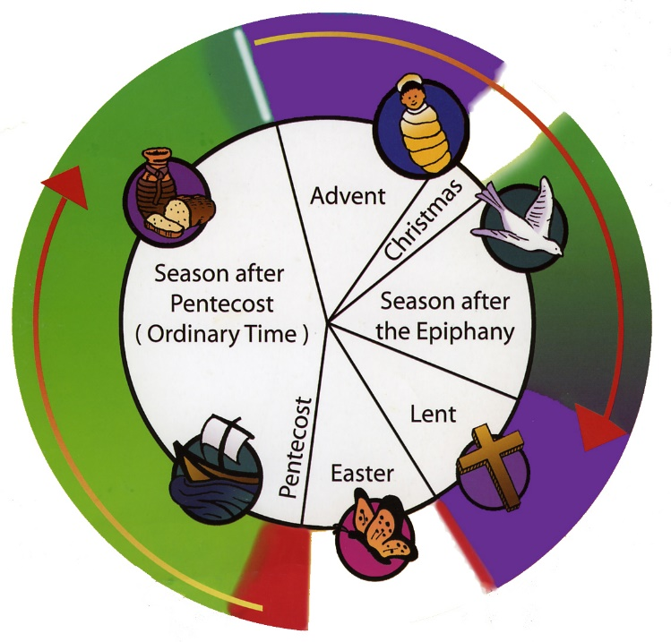

|  |  |  |
| --- | --- | --- |
| Teacher Led | Liturgical Events | Celebration |
| Church | Singing | Pupil Led |