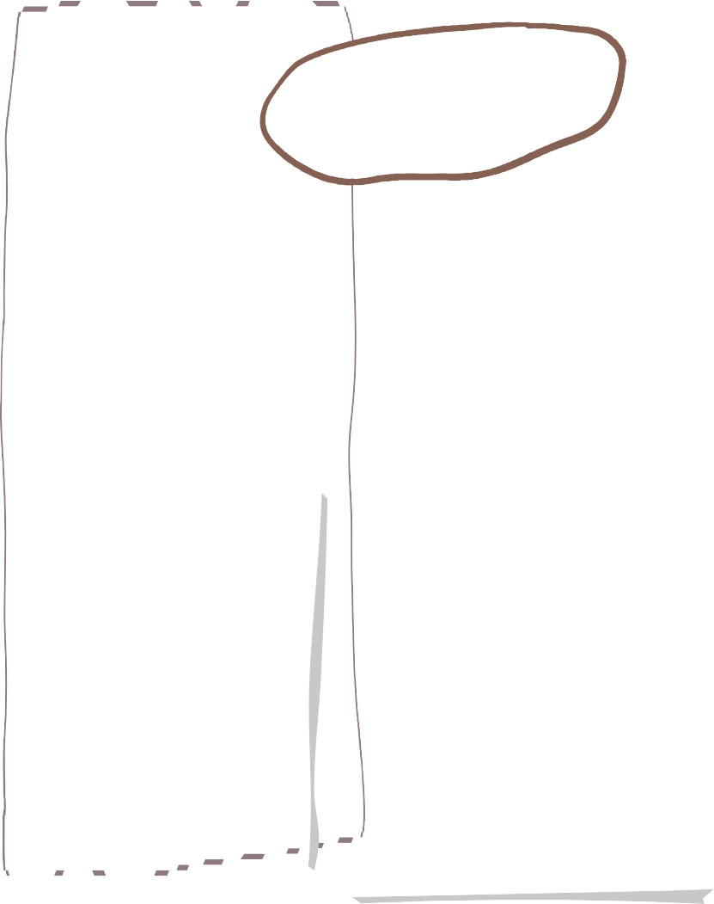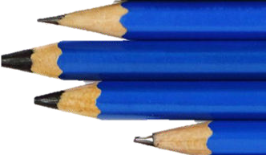

**Autumn Term Oak Class**

**Science**

**Maths**

**English**

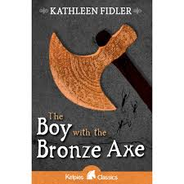

Autumn term focus - using resources from Grammarsaurus. The emphasis is on children’s knowledge of basic sentence building including subjects and verb agreements.

**We are reading…**

**Y3&4**

**Step 1 Hundreds, tens and ones**

**Step 2 Represent numbers to 1,000**

**Step 3 Partition numbers to 1,000**

**Step 4 Thousands**

**Step 5 Represent numbers to 10,000**

**Step 6 Partition numbers to 10,000**

**Step 7 Flexible partitioning**

**Step 8 Find 1, 10, 100 or 1,000 more or less**

**Step 9 Number line to 1,000**

**Step 10 Number line to 10,000**

**Step 11 Estimate on a number line**

**Step 12 Compare numbers**

**Step 13 Order numbers**

**Step 14 Round to the nearest 10**

**Step 15 Round to the nearest 100**

**Step 16 Round to the nearest 1,000**

**Y5&6**

**Step 1 Roman numerals to 1,000**

**Step 2 Numbers to 100,000**

**Step 3 Numbers to 1,000,000**

**Step 4 Read and write numbers to 1,000,000**

**Step 5 Numbers to 10,000,000**

**Step 6 Read and write numbers to 10,000,000**

**Step 7 Powers of 10**

**Step 8 Partition numbers to 10,000,000**

**Step 9 Number line to 10,000,000**

**Step 10 Compare and order any integers**

**Step 11 Round within 100,000**

**Step 12 Round any integer Step 13 Count through zero**

**Step 14 Compare and order negative numbers**

**Step 15 Calculate with negative numbers**

**Enquiry Questions:**

* **Y3/4 What happens when I turn a switch on?**
* **Y5/6 Do I have the power to control electricity?**
  + What is electricity?
  + How can we make electricity safe?
  + Good conductor, bad conductor?
  + Y3/4 - TAPS assessment – Does it conduct electricity?
  + Y5/6 - TAPS assessment – Conductor dough
  + Can I solve an electrical problem?
  + Y3/4 - How can I turn a lamp on and off?
  + **Y5/6 - Can I change the brightness of a lamp?**
  + **Y3/4 - Can I turn a door into an alarm?**
  + **Y5/6 - Can I affect how quickly a motor spins?**

**Prehistoric art**

* Improve mastery of art and design techniques,
* Develop drawing, painting and sculpture with a range of materials
* Study great artists i.e. Picasso, architects and designers in history.
* Opportunities to increase awareness of different kinds
* of art, craft and design.
* Study of work in Chauvet Cave and Cueva de las Manos

**Art**

**History**

**Geography**

**DT**

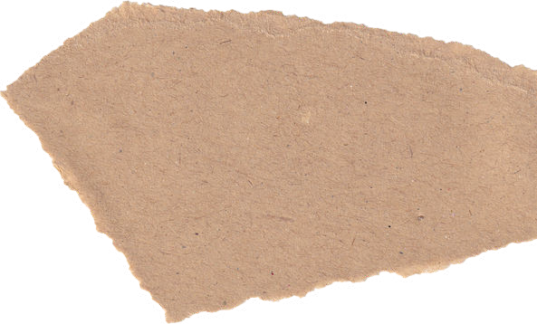

**How can tectonics affect us?**

**Engineers**

* Understand and use electrical systems in their products [for example, series circuits - incorporating switches, bulbs, buzzers and motors].
* Select from and use a wider range of tools and equipment to perform practical tasks [for example, cutting, shaping, joining and finishing].
* Select from and use a wider range of materials and components, including construction materials, textiles and ingredients.

**Why did settlements change from the Stone Age to the Iron Age?**

* What was life like in the Paleolithic?
* What was life like in the Mesolithic?
* What key changes took place during the Neolithic?
* How did daily life change from the Stone Age to the Iron Age?
* What was life like in the South West during the Stone Age?
* Assess: Why did settlements change from the Stone Age to the Iron Age?
* What is under our feet?
* How is a mountain formed?
* How are volcanoes formed?
* Would you live near a volcano?
* Why do earthquakes happen?
* Would you live on a fault line?
* How can tectonics affect us?

**How does faith help people in Cornwall when life gets hard?**

* Questions about life, death, suffering, and what matters most in life.
* Explore how some people might thank God in good times, and how, more broadly, living a life of gratitude can lead to happier and healthier lives.
* Explore ways in which religions help people to live, even when times are tough.
* Comprehend the idea that most religious traditions teach about some form of life after death.
* Learn some key concepts about life after death.

**Meet my French Family**

* Recognise words that are similar to English.
* Notice patterns in word order.
* Adapt a sentence to change the meaning.
* Use a negative expression.
* Apply some understanding of French pronunciation.
* Present ideas and information orally.

**French**

**RE**

**PSHE**

**SCARF**

* Relationships
* Valuing Difference